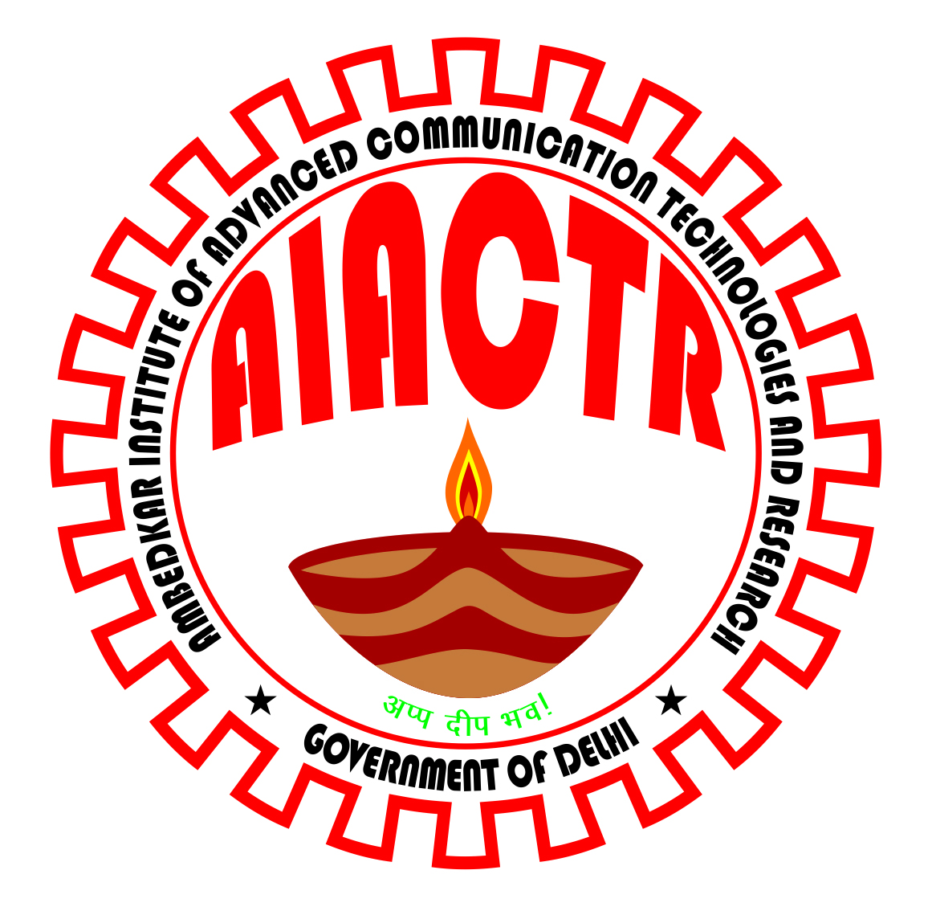Govt. of NCT of Delhi
DEPARTMENT OF TRAINING & TECHNICAL EDUCATION
AMBEDKAR INSTITUTE OF ADVANCED COMMUNICATION TECHNOLOGIES AND RESEARCH
GEETA COLONY DELHI -110031, Phone No. 011-22048046

WALK-IN INTERVIEW
(for engagement on purely contract basis)

The walk-in-interviews for the following posts of AIACT&R, Geeta Colony, Delhi-110031, established under the Department of Training & Technical Education, Muni Maya Ram Marg, Pitam Pura, New Delhi-110088 as per schedule mentioned against the discipline. The engagement will be on purely contract basis upto 28/02/2013 or till such time the posts are filled on regular basis through UPSC, whichever is earlier:-
Time of Reporting – From 9:30 AM to 2:30 PM)
Venue for the Interview: Department of Training & Technical Education, Muni Maya Ram Marg, Pitam Pura, New Delhi-110088)

S. No. | Discipline | Name of the Post | Total No. of vacant Posts | No. of posts reserved | Date of Interview
1 | Electronics and Communication Engg. | Associate Professor | 02 | UR-01  OBC-01 | 03/11/2012
1 | Electronics and Communication Engg. | Assistant Professor | 06 | UR-04  OBC-02 | 03/11/2012
2 | Computer Science and Engg. | Associate Professor | 02 | UR-01  OBC-01 | 04/11/2012
2 | Computer Science and Engg. | Assistant Professor | 06 | UR-03  OBC-02  SC-01 | 04/11/2012
3 | Mechanical Engg. | Assistant Professor | 02 | UR-01  ST-01 | 03/11/2012
4 | Electrical Engg. | Assistant Professor | 01 | UR-01 | 03/11/2012
5 | Applied Mathematics | Associate Professor | 01 | UR-01 | 04/11/2012
5 | Applied Mathematics | Assistant Professor | 01 | SC-01 | 04/11/2012
6 | Applied Physics | Assistant Professor | 01 | UR-01 | 04/11/2012
7 | Applied Chemistry | Assistant Professor | 01 | OBC-01 | 04/11/2012
8 | English and Communication Skill | Assistant Professor | 01 | UR-01 | 04/11/2012
9 |  | Training & Placement Officer | 01 | UR-01 | 03/11/2012
10 |  | Librarian | 01 | UR-01 | 03/11/2012
Contractual Remuneration Per Month is as given below:
- TPO : Rs. 74,892/-
- Associate Professor : Rs. 73,312/-
- Assistant Professor & Librarian: Rs. 34,128/-

The educational Qualifications, work experience and other qualifications required of prospective candidates for the posts at serial No. 1 to 8 are as per the Gazette of India, AICTE notification dated 5th March, 2010 and that for at serial No.9 & 10 as per the Gazette of India, UGC notification dated 30th June, 2010 both w.r.t. the 6th Pay Commission. For all these posts, including that of the TPO and the Librarian educational qualifications, work experience and other qualifications required are also available on the institute website: www.aiactr.ac.in

Other Terms & Conditions

- Age Limit: 35 years for Assistant Professor and 50 years for all other posts.
- Retired and eligible persons below the age of 70 years can also apply; however, for such persons, if appointed, their pay will be fixed as per the provisions contained in the CCS (re-employed pensioners) Rules, 1986.
- Appointment to the above posts is purely a stop-gap arrangement and for a period & conditions stated above.
- Number of posts may vary without any further notifications.
- If candidates are not available / found suitable for senior positions, the department may consider, (subject to approval by the Competent Authority) candidates for lower positions against advertised senior positions.
- Candidates claiming benefits against reserved category should produce Original Certificate in support of their claims. In case of OBC/SC/ST category of candidates, they must produce OBC/SC/ST certificate issued by the Competent Authority of Government of NCT of Delhi only. All other OBC/SC/ST category candidates with certificates issued from outside of Delhi will be treated at par with the General category candidates, if otherwise found eligible.

Interested persons should bring their written /typed application addressed to The Principal Secretary, DTTE and submit the same in his office at the time of interview along with complete documents (applications on plain paper, original certificates along with one attested copy of each, one passport size photograph etc.). No TA/DA will be given for appearing in the interview.

This is issued with prior approval of the Competent Authority.

PRINCIPAL
AIACT&R

